**Addition of Vectors:** It’s just adding each elements of all vectors which will generate a new vector.

**Multiplication of two vector:**

**Note:** when we say a vector of size n , we consider it a column vector by default. By default, we assume all vectors to be column vectors unless otherwise stated to avoid confusion.

There are two types of multiplication **dot product and cross product** (cross product is not much used In ML so we look at dot product).

Suppose there are two vectors **a**  and **b,** now the dot product is similar to matrix multiplication (where resultant matrix have row = no of rows in 1st matrix, and col = no of cols in 2nd matrix), so for two vector dot product would give a single digit output.

Since both are column vector, so we have take transpose of first vector (ie **a**) and then perform matrix multiplication with second vector (ie **b**).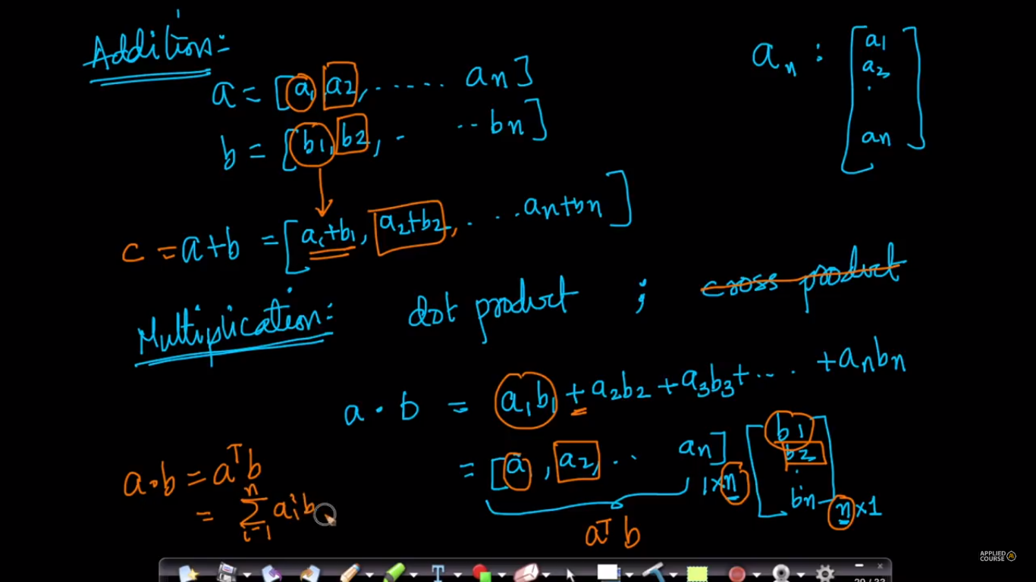

**Usage of dot product in ML:**

A dot product will tell you how similar in direction vector **a** is to vector **b** through the measure of the angle between them. For example, If you have three images, one of a dog another of a cat, and one unknown; and you would like a machine learning algorithm to tell you which one of {dog, cat} is the more likely label for the unknown image. If the 'vector' of your unknown image is closer in direction to the direction of the 'dog vector' it will classify as dog, otherwise it will classify as cat.

In deep learning, for example - classification is done hierarchically. There are many, many, many layers of successive 'dot-product classifications' before an answer is produced.

Dot product can also be calculated as:

a.b = ||a|| ||b|| cosθ

where,

||a|| = length of vector a

||b|| = length of vector b

So, on the basis of this We can conclude one more thing as:

Since cos 90* (both vectors are perpendicular to each other) is 0, which on computing dot product gives 0, that means if we have given two vectors, and their dot product computed (using matrix mul) 0, that means both vectors are perpendicular to each other.

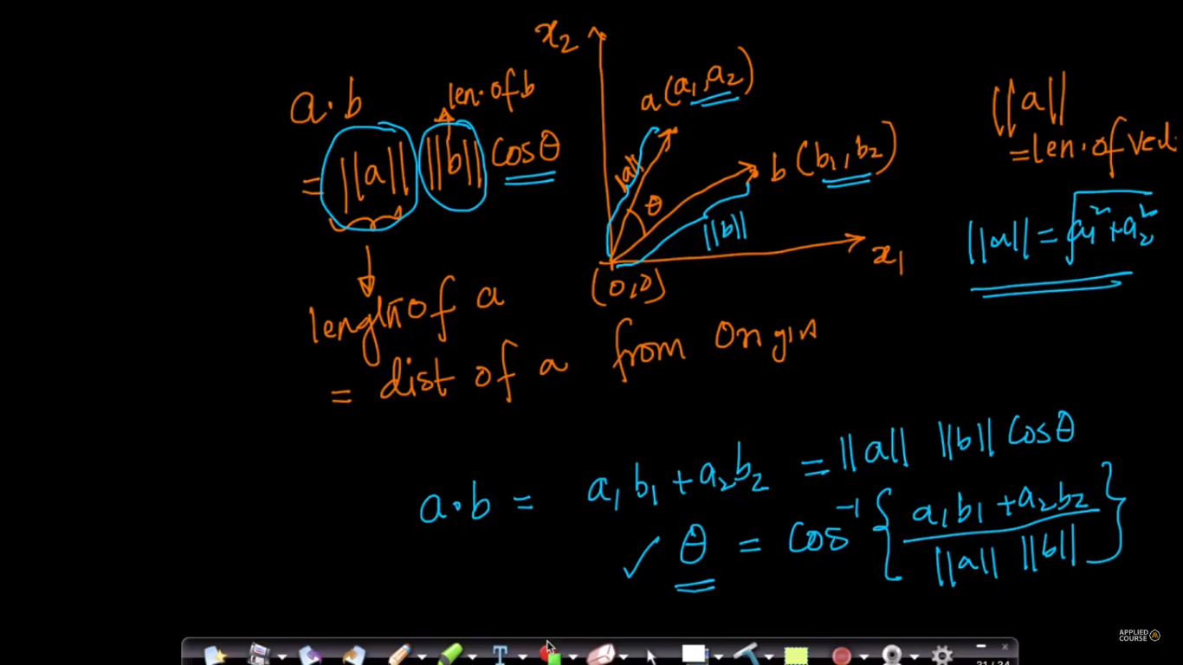

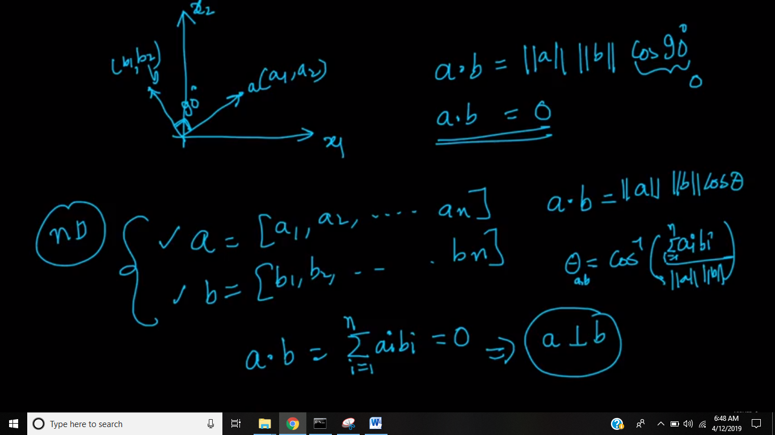

If we multiply a vector with itself then it’s dot product is **square of the length of that vector.**

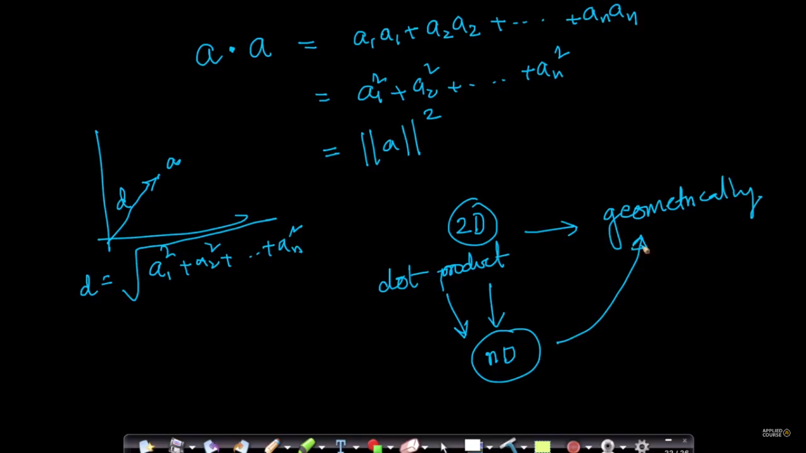

**Why do we use cosine as feature in dot product.**

the cos function is greater for smaller angles, and lesser for larger ones, just like the length of the projection, since in dot product our aim is to find how similar two vectors and hence we use cos function as for cos 0 value is 1 that is they are highly similar and for cos 90 value is 0 that means there is no similarity.

In mathematical term The dot product of two vectors AA and BB is just the product of the magnitude of one vector with the scalar projection of the other one on itself.



